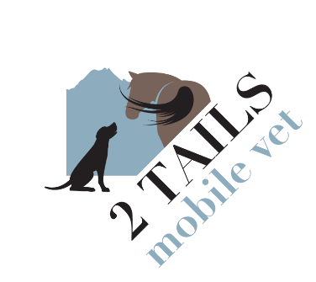
EUTHANASIA CONSENT FORM

I, the undersigned, am the owner or duly authorized agent of the owner of the animal:

(Pet’s name, age and color or breed here)___________________________________________________
I verify that the above animal has not bitten any person or animal during the last ten (10) days and to the best of my knowledge has not been exposed to rabies. I request and consent to humane euthanasia for my pet understanding that humane euthanasia causes death and is irreversible. I release Dr. Julie Stafford and 2 Tails Veterinary Services LLC from any and all claims arising from or connected with this life-ending procedure and the subsequent care of my pet’s remains.
I WOULD ___ WOULD NOT ___ like a keepsake nose print charm (Gold $99.99 or Silver $69.99)
It is my desire to provide the following aftercare for my pet and understand that I am responsible for communicating these wishes to PASSAGES PET CREMATION AND GRIEF CENTER and associated costs:
___ Private cremation with ashes saved (pets are walled off and no mixing of ashes will occur)
___ Communal cremation with no return of ashes. My pet’s remains will not be returned to me.
I WOULD ___ WOULD NOT ___ like a keepsake pawprint to be done on my pet (for cremations only).
I WOULD ___ WOULD NOT ___ like a keepsake lock of fur to be kept from my pet (for cremations only).

___ Owner to care for body with adherence to municipal, borough, and state law.

Is there a veterinary clinic we can contact to inform of your pet’s passing? ________________________

Signature:________________________________________ Date:__________________

Name:___________________________________________
Mailing address:________________________________________________
_____________________________________________________________
Phone number:____________________________________

